Handout Hyperelasticity material modeling
Problem description:
- To find the axial stiffness of the rubber mount
- To identify any areas of high maximum principal stress that might limit the fatigue life of the mount.
Known:
The mount is bonded at both ends to steel plates. It will experience axial loads up to 5.5 kN distributed uniformly across the plates. The cross-section geometry and dimensions are given.
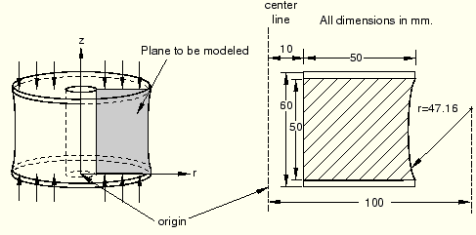
You will examine the static response of the mount; therefore, you will use ABAQUS/Standard for your analysis.

1 Symmetry
In axisymmetric analyses with axisymmetric elements—such as this rubber mount example—we need model only the cross-section of the component. The element formulation automatically includes the effects of axial symmetry.

2 Preprocessing—creating the model with ABAQUS/CAE
Part definition
Create an axisymmetric, deformable, shell part. Name the part Mount, and specify an approximate part size of 0.3. Because of symmetry considerations, only the bottom half of the mount will be modeled.
When you first enter the sketcher, the axis of revolution is displayed as a green dashed line with a fixed position constraint; your sketch cannot cross this axis.
To sketch the mount geometry:
- Draw an arbitrary rectangle to the right of the axis of symmetry.
  - Set the horizontal distance between the axis of symmetry and the left edge of the rectangle to 0.01 m.
  - Set the vertical height of the rectangle to 0.030 m and its horizontal span to 0.050 m.
- Sketch a circle using the Create Circle: Center and Perimeter tool. Select any point to the rectangle’s right as the center, and snap the perimeter point to the right edge of the rectangle.
  - Set the horizontal distance between the axis of symmetry and the center of the circle to 0.1 m.
  - Set the vertical distance between the center of the circle and the top-right vertex of the rectangle to 0 m.
  - Set the vertical distance between the perimeter point (where the circle snaps to the rectangle) and the bottom-right vertex of the rectangle to 0.005 m.
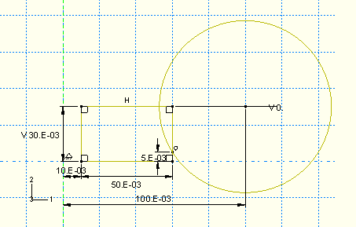
- Use the Auto-Trim tool to remove the excess portions of the sketch.
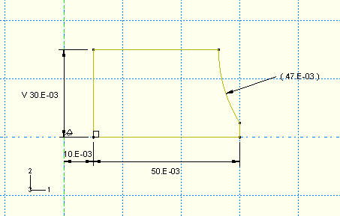
Material properties: hyperelastic model for the rubber
You have been given some experimental test data for the rubber material used in the mount. Three different sets of test data—a uniaxial test, a biaxial test, and a planar (shear) test—are available.
Note: Volumetric test data are not required when the material is incompressible (as is the case in this example).
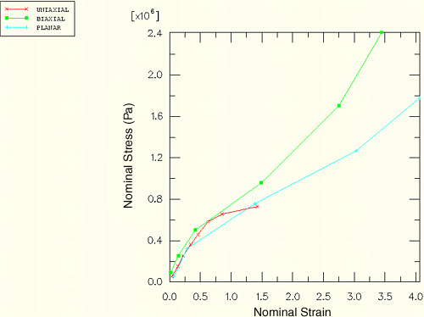
Uniaxial test data | Biaxial test data | Planar test data
  Stress (Pa) | Strain
  5.40E+04 | 0.038
  1.52E+05 | 0.1338
  2.54E+05 | 0.221
  3.62E+05 | 0.345
  4.59E+05 | 0.46
  5.83E+05 | 0.6242
  6.56E+05 | 0.851
  7.30E+05 | 1.4268
  Stress (Pa) | Strain
  8.90E+04 | 0.02
  2.55E+05 | 0.14
  5.03E+05 | 0.42
  9.58E+05 | 1.49
  1.70E+06 | 2.75
  2.41E+06 | 3.45
  Stress (Pa) | Strain
  5.50E+04 | 0.069
  3.24E+05 | 0.2828
  7.58E+05 | 1.3862
  1.27E+06 | 3.0345
  1.78E+06 | 4.0621
When you define a hyperelastic material using experimental data, you also specify the strain energy potential (Refer to the other handout, Strain energy potential) that you want to apply to the data. ABAQUS uses experimental data to calculate the coefficients necessary for the specified strain energy potential.
To define and evaluate hyperelastic material behavior:
- Create a hyperelastic material named Rubber. In this example a first-order, polynomial strain energy function is used to model the rubber material; thus, select Polynomial from the Strain energy potential list in the material editor. Enter the test data given above using the Test Data menu items in the material editor.
To visualize the experimental data, click mouse button 3 on the table for any of the test data and select Create X–Y Data from the.
In general, you may be unsure of which strain energy potential to specify. In this case, you could select Unknown from the Strain energy potential list in the material editor. You could then use the Evaluate option to guide your selection by performing standard tests with the experimental data using multiple strain energy potentials.
- In the Model Tree, click mouse button 3 on Rubber underneath the Materials container. Select Evaluate from the menu that appears to perform the standard unit-element tests (uniaxial, biaxial, and planar). Specify a minimum strain of 0 and a maximum strain of 1.75for each test. Evaluate only the first-order polynomial strain energy function. This form of the hyperelasticity model is known as the Mooney-Rivlin material model.
When the evaluation is complete, ABAQUS/CAE enters the Visualization module. A dialog box appears containing material parameter and stability information. An X–Y plot of nominal stress–nominal strain curve for the material as well as a plot of experimental data also appears for each test.
1. Comparison of experimental data (solid) and ABAQUS/Standard results (dashed): biaxial tension.
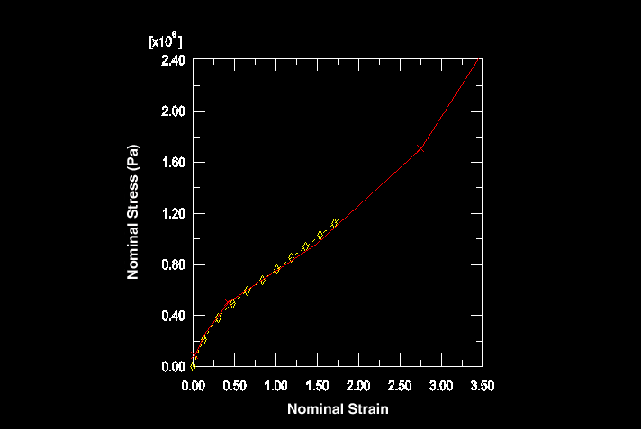
2. Comparison of experimental data (solid) and ABAQUS/Standard results (dashed): uniaxial tension.
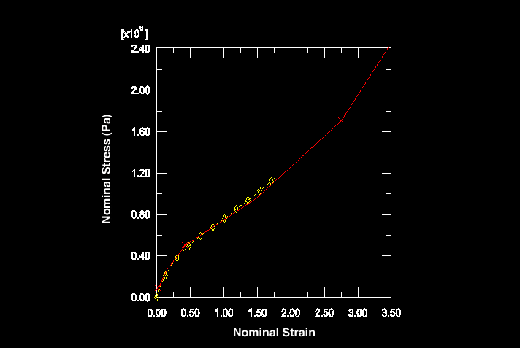
3. Comparison of experimental data (solid) and ABAQUS/Standard results (dashed): planar shear.
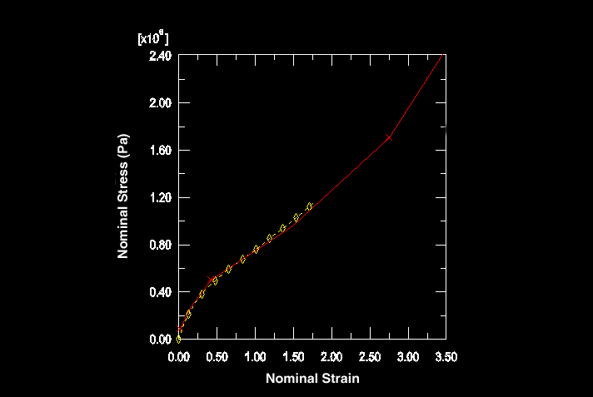
The hyperelastic material parameters
The hyperelastic material coefficients—C₁₀, C₀₁, D₁—that ABAQUS calculates from the material test data appear in the Material Parameters and Stability Limit Information dialog box. The material model is stable at all strains with these material test data and this strain energy function.
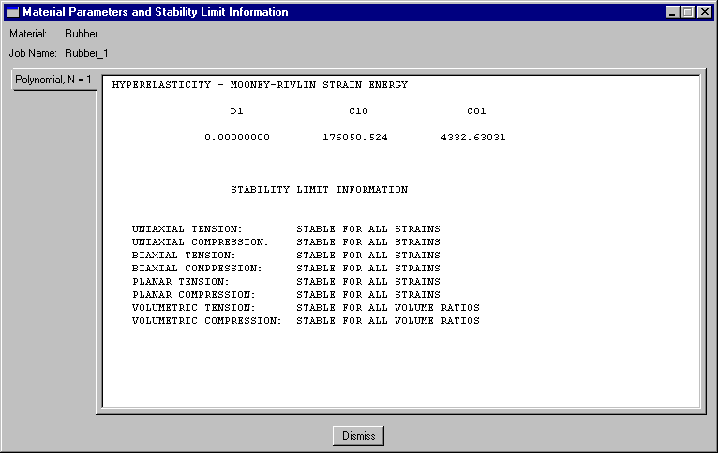
If you specified that a second-order (N=2) polynomial strain energy function be used, you would see warnings as shown below. If you had only uniaxial test data for this problem, you would find that the Mooney-Rivlin material model ABAQUS creates would have unstable material behavior above certain strain magnitudes.
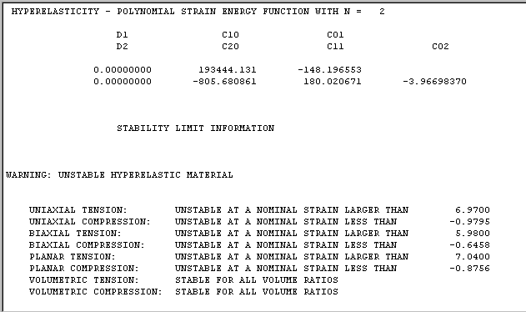
Completing the material and section definitions and assigning section properties
The steel is modeled with linear elastic properties only ( = 200 × 10⁹ Pa, = 0.3).
Create two homogeneous solid section definitions: one named RubberSection that refers to the rubber material and one named SteelSection that refers to the steel material.
Before assigning section properties, partition the part into the two regions using the Partition Face: Sketch tool.
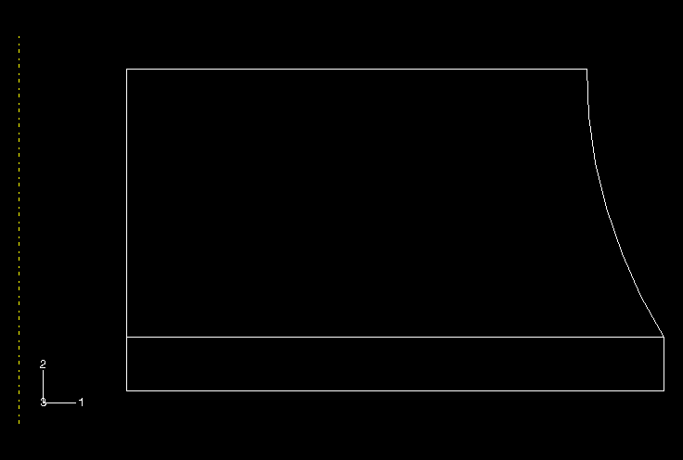
1. In the Sketcher, draw a horizontal line extending from the point where the circular arc intersects the right edge to any point past the left edge of the sketch.
2. The upper region represents the rubber mount, while the lower region represents the steel plate. Assign the appropriate section definitions to each region.
Creating an assembly and a step definition
Create a dependent instance of the part. In this simulation you can accept the default r–z (1–2) axisymmetric coordinate system.
Define a single static, general step named Compress mount.
1. Toggle on Nlgeom.
2. Set the total step time to 1.0 and the initial time increment to 0.01.
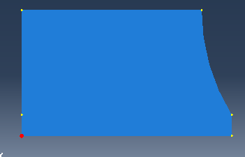
For the purpose of restricting output, create a geometry set named Out at the vertex located at the lower-left corner of the steel plate region.

Output requests:
1, Write the preselected variables and nominal strains as field output to the output database file every increment.
2, Write the displacements at a single point on the bottom of the steel plate to the output database file as history data so that the stiffness of the mount can be calculated. Use the geometry set Out for this purpose.
Applying loads and boundary conditions
Specify boundary conditions for the region on the symmetry plane (U2 = 0 and YSYMM would be equivalent in this case).
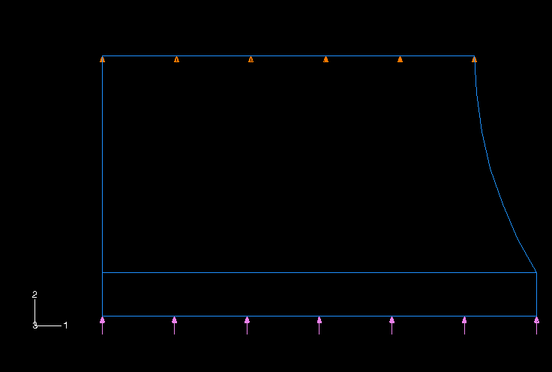
The mount must carry a maximum axial load of 5.5 kN, the magnitude of the pressure is given by
Creating the mesh and the job
Use first-order, axisymmetric, hybrid solid elements (CAX4H) for the rubber mount.
Create a structured quadrilateral mesh. Seed the part by specifying the number of elements along the edges (by selecting SeedEdge By Number or the tool). Specify 30 elements along each horizontal edge, 14 elements along the vertical and curved edges of the rubber, and 1 element along the vertical edges of the steel. 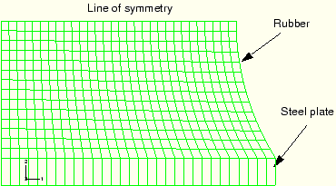
Create a job named Mount. Give the job the following description: Axisymmetric mount analysis under axial loading.
Save your model in a model database file, and submit the job for analysis.

3 Postprocessing
Enter the Visualization module, and open the file Mount.odb.
Calculating the stiffness of the mount
Determine the stiffness of the mount by creating an X–Y plot of the displacement of the steel plate as a function of the applied load. You will first create a plot of the vertical displacement of the node on the steel plate for which you wrote data to the output database file. Data were written for the node in set Out in this model.
To create a history curve of vertical displacement and swap the X- and Y-axes:
- In the Results Tree, expand the History Output container underneath the output database named Mount.odb.
- Locate and select the vertical displacement U2 at the node in set Out.
- Click mouse button 3, and select Save As from the menu that appears to save the X–Y data.
The Save XY Data As dialog box appears.
- Type the name DISP, and click OK.
- In the Results Tree, double-click XYData.
The Create XY Data dialog box appears.
- Select Operate on XY data, and click Continue.
- In the Operate on XY Data dialog box, from Operators, click swap(X). swap( ) appears in the text field at the top of the dialog box.
- In the XY Data field, double-click DISP. The expression swap( "DISP" ) appears in the text field at the top of the dialog box.
- Click Save As at the bottom of the dialog box. In the Name text field, type SWAPPED; and click OK to close the dialog box.
- To view the swapped plot of time-displacement, click Plot Expression at the bottom of the Operate on XY Data dialog box.
You now have a curve of time-displacement. What you need is a curve showing force-displacement. This is easy to create because in this simulation the force applied to the mount is directly proportional to the total time in the analysis. All you have to do to plot a force-displacement curve is multiply the curve SWAPPED by the magnitude of the load (5.5 kN).
To multiply a curve by a constant value:
- In the Operate on XY Data dialog box, click Clear Expression.
- In the XY Data field, double-click SWAPPED.
The expression "SWAPPED" appears in the text field at the top of the dialog box. Your cursor should be at the end of the text field.
- Multiply the data object in the text field by the magnitude of the applied load by entering *5500.
- Save the multiplied data object by clicking Save As at the bottom of the dialog box.
The Save XY Data As dialog box appears.
- In the Name text field, type FORCEDEF; and click OK to close the dialog box.
- To view the force-displacement plot, click Plot Expression at the bottom of the Operate on XY Data dialog box.
You have now created a curve with the force-deflection characteristic of the mount (the axis labels do not reflect this since you did not change the actual variable plotted). To get stiffness, you need to differentiate the curve FORCEDEF. You can do this by using the differentiate() operator in Operate on XY Data dialog box.
To obtain the stiffness:
- In the Operate on XY Data dialog box, clear the current expression.
- From the Operators listed, click differentiate(X).
differentiate( ) appears in the text field at the top of the dialog box.
- In the XY Data field, double-click FORCEDEF.
The expression differentiate( "FORCEDEF" ) appears in the text field.
- Save the differentiated data object by clicking Save As at the bottom of the dialog box.
The Save XY Data As dialog box appears.
- In the Name text field, type STIFF; and click OK to close the dialog box.
- To plot the stiffness-displacement curve, click Plot Expression at the bottom of the Operate on XY Data dialog box.
- Click Cancel to close the dialog box.
- Open the Axis Options dialog box and switch to the Title tabbed page.
- Customize the axis titles.
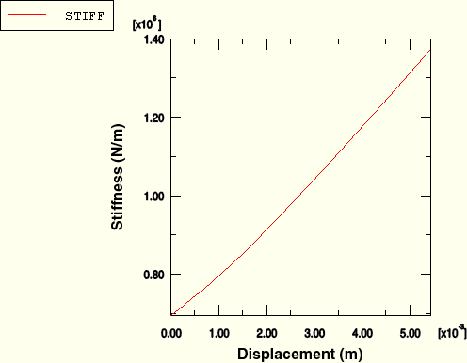
- Click Dismiss to close the Axis Options dialog box.
The stiffness of the mount increases by almost 100% as the mount deforms. This is a result of the nonlinear nature of the rubber and the change in shape of the mount as it deforms. Alternatively, you could have created the stiffness-displacement curve directly by combining all the operators above into one expression.

To define the stiffness curve directly:
- In the Results Tree, double-click XYData.
The Create XY Data dialog box appears.
- Select Operate on XY data, and click Continue.
The Operate on XY Data dialog box appears.
- Clear the current expression; and from the Operators listed, click differentiate(X).
differentiate( ) appears in the text field at the top of the dialog box.
- From the Operators listed, click swap(X).
differentiate( swap( ) ) appears in the text field.
- In the XY Data field, double-click DISP.
The expression differentiate( swap( "DISP" ) ) appears in the text field.
- Place the cursor in the text field directly after the swap( "DISP" ) data object, and type *5500 to multiply the swapped data by the constant total force value.
differentiate( swap( "DISP" )*5500 ) appears in the text field.
- Save the differentiated data object by clicking Save As at the bottom of the dialog box.
The Save XY Data As dialog box appears.
- In the Name text field, type STIFFNESS; and click OK to close the dialog box.
- Click Cancel to close the Operate on XY Data dialog box.
- Customize the X- and Y-axis labels if you have not already done so.
- In the Results Tree, click mouse button 3 on STIFFNESS underneath the XYData container and select Plot from the menu that appears to view the plot above that shows the variation of the mount's axial stiffness as the mount deforms.

Contouring the maximum principal stress
Plot the maximum in-plane principal stress in the model. Follow the procedure given below to create a filled contour plot on the actual deformed shape of the mount with the plot title suppressed.
To contour the maximum principal stress:
- From the main menu bar, select ResultField Output.
The Field Output dialog box appears; by default, the Primary Variable tab is selected.
- From the list of output variables, select S if it is not already selected.
- From the list of invariants, select Max. Principal.
- Click OK.
The Select Plot State dialog box appears.
- Toggle on Contour, and click OK.
ABAQUS/CAE displays a contour plot of the maximum in-plane principal stresses.
- Open the Contour Plot Options dialog box.
- Drag the uniform contour intervals slider to 8.
- Click OK to view the contour plot and to close the dialog box.
Create a display group showing only the elements in the rubber mount.
- In the Results Tree, expand the Materials container underneath the output database file named Mount.odb.
- Click mouse button 3 on RUBBER, and select Replace from the menu that appears to replace the current display with the selected elements.
The viewport display changes and displays only the rubber mount elements.
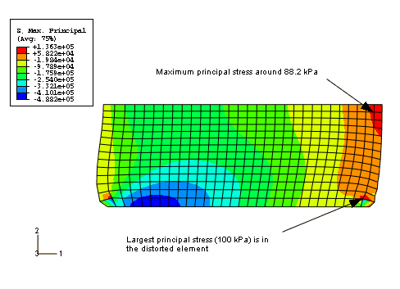
The maximum principal stress in the model, reported in the contour legend, is 136 kPa. Although the mesh in this model is fairly refined and, thus, the extrapolation error should be minimal, you may want to use the query tool to determine the more accurate integration point values of the maximum principal stress.
When you look at the integration point values, you will discover that the peak value of maximum principal stress occurs in one of the distorted elements in the bottom right-hand part of the model. This value is likely to be unreliable because of the levels of element distortion and volumetric locking. If this value is ignored, there is an area near the plane of symmetry where the maximum principal stress is around 88.2 kPa.
The easiest way to check the range of the principal strains in the model is to display the maximum and minimum values in the contour legend.

To check the principal nominal strain magnitude:
- From the main menu bar, select ViewportViewport Annotation Options.
The Viewport Annotation Options dialog box appears.
- Click the Legend tab, and toggle on Show min/max values.
- Click OK.
The maximum and minimum values appear at the bottom of the contour legend in the viewport.
- From the main menu bar, select ResultField Output.
The Field Output dialog box appears; by default, the Primary Variable tab is selected.
- From the list of output variables, select NE.
- From the list of invariants, select Max. Principal if it is not already selected.
- Click Apply.
The contour plot changes to display values for maximum principal nominal strain. Note the value of the maximum principal nominal strain from the contour legend.
- From the list of invariants in the Field Output dialog box, select Min. Principal.
- Click OK to close the Field Output dialog box.
The contour plot changes to display values for minimum principal nominal strain. Note the value of the minimum principal nominal strain from the contour legend.
The maximum and minimum principal nominal strain values indicate that the maximum tensile nominal strain in the model is about 100% and the maximum compressive nominal strain is about 56%. Because the nominal strains in the model remained within the range where the ABAQUS hyperelasticity model has a good fit to the material data, you can be fairly confident that the response predicted by the mount is reasonable from a material modeling viewpoint.

